
BRAC University

Function; Domain & Range

Problems:

Find out the domain and range of the following functions:

- 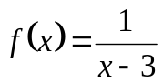 11. 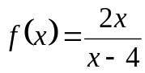
- 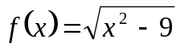 12. 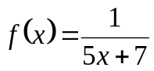
- 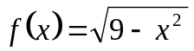 13. 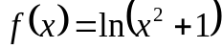
- 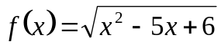 14. 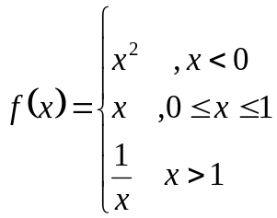
- 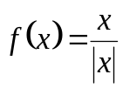 15. 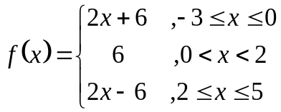
- 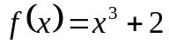 16. 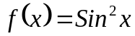
- 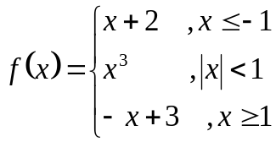 17. 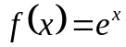
- 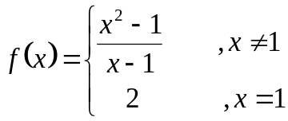 18. 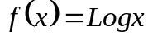
- 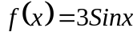 19. 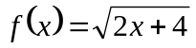
10. 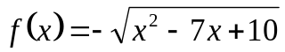

Sketch the above functions if possible.

You are responsible to study problems from reference books as well to improve your knowledge.

